Laurice Sattouf

Choi Tim Anthony Young

Dimitri Garcia

ECE4304- Lab 8

4/26/2021

Professor M. Aly

**Text Display with UART Control**

**Purpose:**

* Design a system that can display preset text on monitor via VGA output
* The color of the text will be controlled by on board switches
* The position of the text will be controlled by UART input

The schematic of the design is the following:

**Schematic:**

Wrapping all the component created, we end up having the following design:

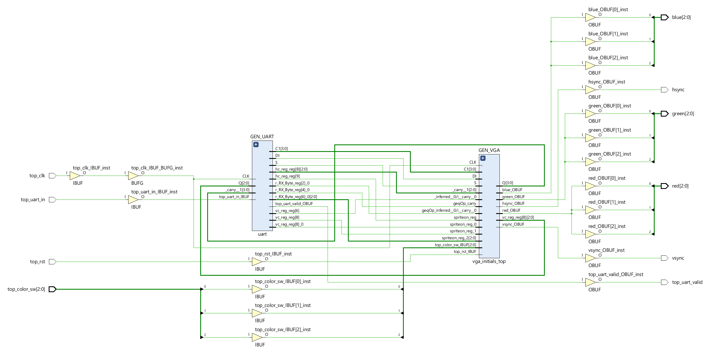

**Power and Resources Used:**

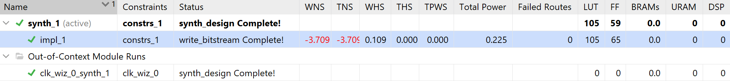

105 lookup tables and 0.225 total power used to implement this design using Vivado.

**Work Contribution:**

* We had a meeting to brainstorm and explain the main idea of the lab, and everyone would work individually to achieve the most optimized design.
* We had a zoom meeting to choose the design with less power consuming, then we were able to demo our implemented design and cover all the corner cases.
* Documentation and reports were evenly distributed, and it covered all the steps of our successfully implemented design.